Varzaru Claudia, 1413

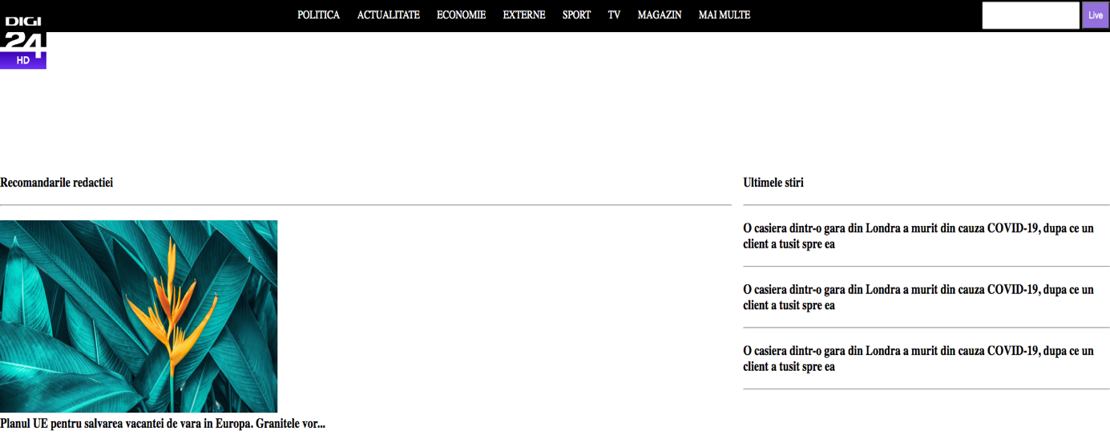

<!DOCTYPE html>

<html>

<head>

<title>Test HTML</title>

<style type="text/css">

*{

padding: 0;

margin: 0;

}

a{

text-decoration: none;

}

ol, ul{

list-style-type: none;

}

#logo{

width: 80px;

position: absolute;

top: 20px;

}

header{

background-color: black;

display: flex;

justify-content: space-between;

align-items: center;

position: relative;

margin-bottom: 200px;

}

ol{

display: flex;

margin-left: 500px;

}

ol li{

padding: 15px;

}

ol li a{

color: #fff;

text-transform: uppercase;

}

input{

padding: 10px;

}

input[type="submit"]{

color: #fff;

background-color: mediumpurple;

}

#central{

display: flex;

}

#stanga{

width: 80%;

margin-right: 20px;

}

hr{

margin: 20px 0;

}

</style>

</head>

<body>

<header>

<img id="logo" src="https://upload.wikimedia.org/wikipedia/commons/thumb/d/df/Logo_Digi_24_%282012%29.svg/1200px-Logo_Digi_24_%282012%29.svg.png"/>

<ol>

<li><a href="#">Politica</a></li>

<li><a href="#">Actualitate</a></li>

<li><a href="#">Economie</a></li>

<li><a href="#">Externe</a></li>

<li><a href="#">Sport</a></li>

<li><a href="#">TV</a></li>

<li><a href="#">Magazin</a></li>

<li><a href="#">Mai multe</a></li>

</ol>

<form action="http://google.ro/search" method="get">

<input type="text" name="q" size=”30” />

<input type="submit" value="Live" />

</form>

</header>

<div id="central">

<div id="stanga">

<h3>Recomandarile redactiei</h3>

<hr>

<div>

<img src="https://images.ctfassets.net/hrltx12pl8hq/3MbF54EhWUhsXunc5Keueb/60774fbbff86e6bf6776f1e17a8016b4/04-nature_721703848.jpg?fit=fill&w=480&h=270" />

</div>

<h3>Planul UE pentru salvarea vacantei de vara in Europa. Granitele vor...</h3>

</div>

<div id="dreapta">

<h3>Ultimele stiri</h3>

<hr>

<div class="stire">

<h3>O casiera dintr-o gara din Londra a murit din cauza COVID-19, dupa ce un client a tusit spre ea</h3>

<hr>

</div>

<div class="stire">

<h3>O casiera dintr-o gara din Londra a murit din cauza COVID-19, dupa ce un client a tusit spre ea</h3>

<hr>

</div>

<div class="stire">

<h3>O casiera dintr-o gara din Londra a murit din cauza COVID-19, dupa ce un client a tusit spre ea</h3>

<hr>

</div>

</div>

</div>

</body>

</html>